
Final Progress Report
Internship Report
On
Rhiti Sports Management Pvt. Ltd.
Session: August 2025 – November 2025
Supervised by:
Mr. Rishi Awasthi
(Lead Tech, Rhiti Sports)
and
Dr. Antim Chauhan
(Assistant Professor, SCSET, Bennett University)
Submitted by:
Vaibhav Gupta
B.Tech (Computer Science Engineering)
Enrollment No. E22CSEU1505
SCHOOL OF COMPUTER SCIENCE ENGINEERING AND TECHNOLOGY,
BENNETT UNIVERSITY
CONTENTS
Chapter 1: Introduction of the Report
Chapter 2: Overview of Organization
Chapter 3: Internship Work Description
Chapter 4: Technical Contributions & Outcomes
Chapter 5: Skills Acquired
Chapter 6: Challenges and Solutions
Chapter 7: Overall Experience and Conclusion
Weekly Work Logs
Annexure

INTERNSHIP OFFER LETTER

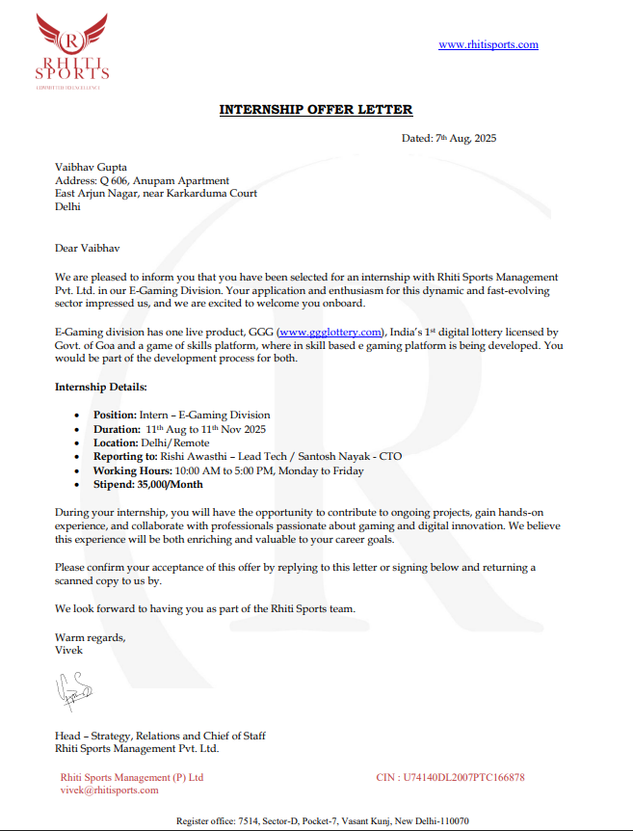

CONFIRMATION MAIL

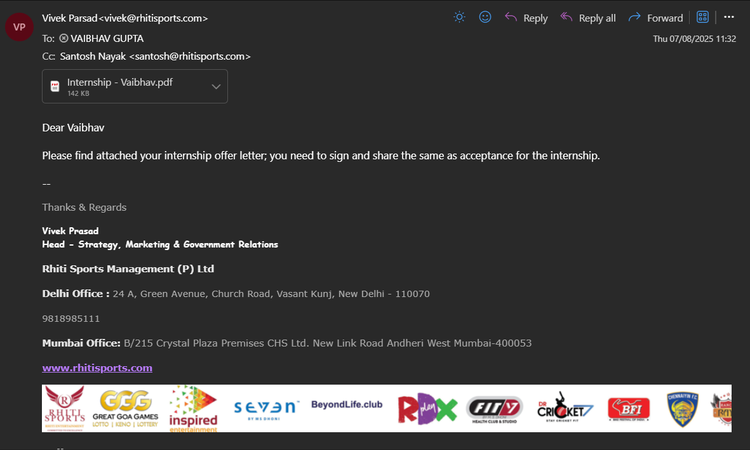

INTERNSHIP COMPLETION CERTIFICATE

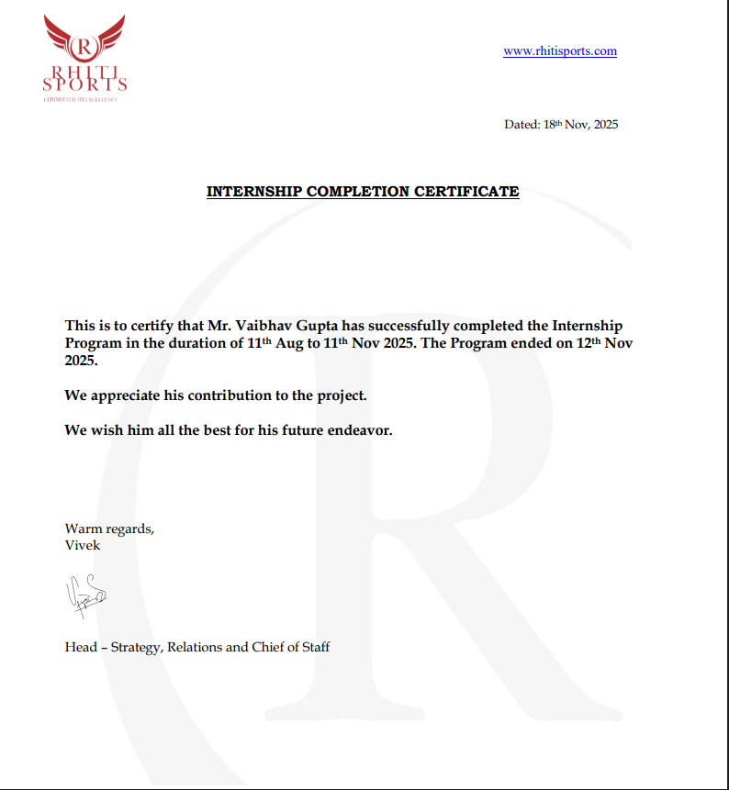

CERTIFICATE

This is to certify that the student named Vaibhav Gupta (Enrollment No. E22CSEU1505) of Programme Name B.Tech (Computer Science Engineering), has undertaken an internship/industry project titled at Rhiti Sports from 11th August 2025 to 11th November 2025. This progress report is a bona fide record of the work completed during the above period.

Internal Guide / Faculty Mentor:
Dr. Antim Chauhan

Industry Mentor:
Mr. Vivek Prasad


ACKNOWLEDGEMENT

I sincerely thank my faculty mentor, Dr. Antim Chauhan, for their continuous guidance and support throughout my internship. I would also like to express my gratitude to my industry mentor, Mr. Vivek Prasad, and the team at Rhiti Sports for providing me the opportunity to work on real-world systems and gain practical exposure. I extend my thanks to the Department of Computer Science and Engineering at Bennett University for facilitating this internship opportunity.

CHAPTER 1: INTRODUCTION OF THE REPORT

Background
The digital gaming industry generates vast amounts of data daily, ranging from user login patterns to micro-transaction histories. To remain competitive, companies like Rhiti Sports Management Pvt. Ltd. (specifically the E-Gaming Division) rely on data science to translate this raw information into strategic assets. This report documents my work as a Data Science Intern, where I focused on building analytical infrastructure to track user behavior, optimize monetization, and enhance platform retention.

Purpose
The purpose of the internship was to gain hands-on experience in building production-grade analytical components for a digital gaming ecosystem. The project was structured to simulate industry-level workflows involving multi-source data integration, stakeholder-driven requirement gathering, and the implementation of business intelligence solutions for high-frequency reporting.
Key intentions of the internship included:
- Applying advanced Python-based data cleaning and ETL automation to streamline the movement of data from raw sources to analytical layers.
- Developing scalable Power BI dashboards enriched with DAX-based KPIs to support strategic decision-making by the product, marketing, and leadership teams.
- Enhancing existing SQL pipelines by optimizing query structures, indexes, and execution plans for reduced latency and improved reporting performance.
- Building analytics models to compute user retention, engagement funnels, revenue patterns, and behavioural insights across different periods.
- Establishing data validation frameworks to ensure integrity, consistency, and reliability across Power BI dashboards, Excel trackers, and raw database outputs.

By executing these tasks, the internship served as a bridge between academic learning and professional implementation, enabling practical exposure in data engineering, BI development, and analytical problem-solving.

Technology Used
The internship involved working with a modern, industry-aligned analytics and data engineering toolkit. Each tool was selected based on scalability, analytical capability, and production relevance.
1. Data Processing & Automation
Python was the core scripting language used for ETL tasks, automation, and exploratory analysis.
Libraries & Use-Cases:
- Pandas – Cleaning, merging, reshaping raw user logs and transaction datasets.
- NumPy – Numerical computation for revenue metrics, retention cohorts, and performance indicators.
- Matplotlib & Seaborn – Trend visualization, anomaly detection, and pre-dashboard analysis.
- OS / Schedule / JSON – Automating daily refresh cycles and processing structured data scripts.
2. Business Intelligence & Visualization
Power BI served as the primary visualization platform.
Capabilities Utilized:
- Data modelling through relationships and fact-dimension structures.
- DAX measures for KPIs such as:
  - Average Revenue Per User (ARPU)
  - Daily Active Users (DAU)
  - Retention Rate (D1, D7, D30)
  - Cohort-based metrics
  - Transaction Health Score
- Automated data refresh using Power BI Gateway.
- Interactive dashboards with drill-throughs, hierarchies, segmentation filters, and slicers.
3. Databases & Query Optimization
Two major relational database systems were used:
- MySQL – For transactional data (purchases, gameplay).
- PostgreSQL – For user activity, session logs, and configuration tables.
Key operations included:
- Index creation and optimization for frequently queried columns.
- Execution plan analysis to identify bottlenecks.
- Use of CTEs (Common Table Expressions) for complex hierarchical aggregations.
- Query rewriting to minimize full-table scans and reduce refresh latency.
4. Validation, Reporting & Collaboration
- Excel – Used for cross-validation, pivot models, lookup-based audits, and reconciliation.
- Git Version Control – For managing Python scripts, SQL files, and documentation.
- Microsoft Teams – For cross-team coordination with Product and Data Engineering units.

Scope of Internship
The internship’s scope encompassed responsibilities across multiple technical layers within the analytics ecosystem:
1. Dashboard Development
Design, development, and deployment of Power BI dashboards for:
- Executive-level decision-making
- Game-level performance reporting
- User retention + cohort analysis
- Revenue monitoring
- Marketing performance channels
2. ETL and Data Pipeline Enhancement
- Building Python scripts for automated extraction and transformation.
- Performing deduplication, standardization, type casting, and schema corrections.
- Applying incremental refresh logic to reduce computation overhead.
3. SQL System Optimization
- Profiling slow queries and implementing optimization strategies.
- Creating indices, partition strategies, and improving join sequences.
- Standardizing SQL templates for repeated reporting workloads.
4. Data Validation & QA
- Designing Excel-based validation models to cross-check dashboard metrics.
- Comparing dashboard outputs against database extracts at multiple aggregation levels.
- Reporting mismatches and resolving discrepancies in coordination with engineering teams.
5. Documentation & Knowledge Transfer
- Creating structured documentation for:
  - ETL flows
  - Data dictionaries
  - Dashboard logic
  - KPI definition sheets
- Preparing final knowledge transfer material for post-internship continuity.
This scope ensured exposure to a broad and realistic data analytics environment, including both engineering and business-facing components.

Objectives
The core objectives of the internship project were to:
- Develop Reporting Infrastructure: Create and deploy interactive Power BI dashboards for visualizing key metrics (KPIs).
- Ensure Data Reliability: Implement ETL automation and database optimization to guarantee data synchronization and accuracy.
- Generate Insights: Perform in-depth data analysis to identify and report on key behavioural trends and revenue drivers.
- Standardize Processes: Document all data pipelines and reporting logic to ensure project scalability.

CHAPTER 2: OVERVIEW OF ORGANIZATION

Rhiti Sports Management Pvt. Ltd. is a diversified Indian sports management and digital entertainment company with operations spanning athlete representation, sports event production, digital media, and emerging technology-driven platforms. Over the years, the organization has strategically expanded into the digital gaming ecosystem, recognizing the massive potential of data-driven e-sports and skill-based gaming in India. With the growth of online gaming revenue, enhanced smartphone penetration, and the adoption of micro-transaction-based platforms, Rhiti Sports aims to build cutting-edge digital gaming solutions supported by robust analytics infrastructure.
The company’s E-Gaming Division functions as a technologically advanced unit responsible for developing, maintaining, and scaling gaming platforms capable of supporting thousands of concurrent users. This division focuses on user acquisition, retention mechanics, reward systems, and gameplay optimization using data science and analytics.

2.1 Major Activities, Products and Services
The activities of the E-Gaming Division are aligned around creating a data-driven, scalable, and engaging gaming experience. The division operates using a blend of engineering, analytics, and product innovation.
1. Digital Gaming Platform Development
The division is responsible for designing and operating skill-based digital games, including:
- Real-time multiplayer gameplay systems
- Transaction-focused game economy
- Tier-based reward and badge systems
- User profiling and segmentation
These platforms generate structured and semi-structured data used for analytics and predictive insights.
2. Data Analytics & User Behaviour Modelling
Data analytics is at the core of platform evolution. Key analytical processes include:
- User lifecycle analysis (New → Active → Loyal → Churn)
- Game session telemetry analysis
- Monetization metrics: ARPU, ARPPU, conversion rate
- Retention analysis (D1 / D7 / D30 cohorts)
- Transaction-level revenue breakdown
- Campaign attribution & marketing effectiveness
Insights from these processes directly influence product features, difficulty balancing, and reward algorithms.
3. BI Reporting & Operational Dashboards
Management requires KPIs that update in near real-time to track:
- Daily Active Users (DAU)
- Monthly Active Users (MAU)
- Total & net revenues
- Conversion rate trends
- Session-level analytics
- Churn spikes & anomaly detection
The E-Gaming Division maintains a full reporting suite built using Power BI, SQL scripts, and automated ETL pipelines.
4. Infrastructure & Data Engineering Operations
Technical backend operations include:
- Database management (MySQL/PostgreSQL)
- Data warehouse design
- Cron-based ETL flows
- Log ingestion and transformation
- Real-time trigger systems
- Cloud storage and backup mechanisms
These operations ensure analytic reliability and consistency for downstream dashboards.

2.2 Hierarchical Structure and Organizational Details
Corporate Structure: The organization operates with a focused hierarchy that promotes specialized expertise. The E-Gaming division functions with agility, resembling a tech startup environment within the larger corporate structure.
Current Status and Focus: The company is currently focused on scaling its digital footprint, using advanced analytics to capture a larger share of the competitive e-gaming market. The focus is on real-time data utilization to make immediate business decisions regarding game difficulty, economy balancing, and user rewards.

2.3 The E-Gaming Division: Operational Workflow
The division follows a streamlined pipeline aligned with analytics operations:
1. Data Generation Layer
Gameplay events, user interactions, and transactions are continuously produced and stored in:
- Transaction Databases
- User Log Systems
- Game Engine Events
This data is extremely granular and forms the foundation for analysis.
2. Data Integration Layer
Raw datasets flow through ETL pipelines that perform:
- Data cleaning
- Schema adjustments
- Type casting
- Deduplication
- Structuring into fact & dimension layers
Your Python-based ETL scripts contributed directly to this layer.
3. Data Warehousing Layer
Processed datasets are stored in database models optimized for:
- BI consumption
- Fast query access
- Cohort analysis
- Segmented reporting
4. BI & Analytics Layer
This is where:
- Power BI dashboards
- DAX models
- KPI trackers
- Validation sheets
- SQL-based reports
are generated and maintained.
Your dashboards, SQL query improvements, and validation frameworks lived in this layer.
5. Decision-Making Layer
Insights delivered to the management team influence:
- Gameplay balancing decisions
- Marketing budgets & user acquisition strategies
- New-user retention tactics
- Revenue optimization
- Product redesign & feature releases

CHAPTER 3: INTERNSHIP WORK DESCRIPTION

This chapter details the operational aspects of the internship, focusing on the team structure, the evolution of my responsibilities, the technology stack utilized in a production environment, and the agile methodologies employed throughout the development of the E-Gaming Analytics Suite.

3.1 Departments and Team Assignment
My primary assignment was within the Data & Analytics Team of Rhiti Sports Management Pvt. Ltd.'s E-Gaming Division. This team operates as the central analytical engine for the platform, converting transactional and behavioral data into strategic business intelligence.

3.1.1 Primary Team: Data & Analytics
The Data & Analytics Team was responsible for the full data lifecycle, from ensuring data integrity to generating final, stakeholder-ready reports. My role directly involved:
- Data Modeling and Transformation: Working with raw data dumps and database logs to structure information for analytical use.
- Business Intelligence (BI) Development: Designing, building, and maintaining interactive dashboards used by management and product teams.
- Performance Engineering: Focusing on the efficiency of data retrieval by optimizing database queries and ETL scripts.

3.1.2 Cross-Functional Collaboration
Success required continuous engagement with two key adjacent teams:
- Product Management Team: Collaborated closely to define the most relevant Key Performance Indicators (KPIs). This partnership ensured that the dashboards delivered business value (e.g., metrics related to monetization and retention) rather than just vanity metrics .
- Data Engineering Team: Worked with the engineering team to align on data schemas, understand data update frequencies, and integrate the analytical Python scripts into the broader production ETL pipelines

3.2 Roles and Detailed Responsibilities
My responsibilities evolved quickly from data consumption to system development, moving from reporting analyst to a key contributor in the analytical pipeline architecture.

3.2.1 Data Modeling and Transformation
I was responsible for the initial data quality control and structuring. This involved:
- Cleaning and Structuring: Using Python (Pandas/NumPy) to handle complex data transformation tasks, such as resolving missing values, standardizing inconsistent data types, and calculating intermediate aggregated metrics (e.g., grouping daily user data by geographic region) .
- ETL Automation: Developing reusable Python scripts that automated the extraction of data from source databases and the loading of clean data into the optimized staging tables, ensuring the analytical pipeline was efficient and repeatable.

3.2.2 Business Intelligence and Dashboard Creation
This was the most visible outcome of the role, requiring a balance of technical expertise and data storytelling.
- Dashboard Design: Architecting the layout and visual hierarchy of the high-impact Power BI dashboards (Executive, Retention, Revenue). This required selecting appropriate visualizations to convey insights quickly.
- DAX Implementation: Writing sophisticated DAX (Data Analysis Expressions) formulas to calculate complex financial and behavioral KPIs, such as Average Revenue Per User (ARPU) and Cohort Retention Rate, directly within the Power BI data model.

3.2.3 Database Query Optimization (Performance Engineering)
A critical technical focus was mitigating the latency issues caused by growing data volumes.
- SQL Performance Tuning: Systematically reviewing and optimizing existing SQL queries in MySQL and PostgreSQL. This included adding indexes on frequently queried columns and restructuring inefficient multi-table joins to significantly reduce data retrieval latency.
- Data Validation and Quality Assurance (QA): Implementing rigorous QA procedures to ensure the integrity of reports. This involved cross-checking aggregated metrics across the three reporting platforms (SQL outputs, Power BI, and Excel models) to maintain stakeholder trust in the data.

3.3 Technologies and Tools Utilized
While the list of technologies is straightforward, the core technical contribution lies in their applied context within the E-Gaming environment. My work involved leveraging each tool to address specific challenges in the data pipeline:
- Python (Pandas/NumPy): ETL and Data Processing
  - Core Application: Python was the backbone for the Extraction and Transformation steps of the ETL pipeline.
  - Applied Example: Using Pandas to normalize unstructured user log data, handle missing values, and calculate sophisticated time-series metrics, such as 7-day rolling averages for user engagement. This automation reduced the manual data cleaning and preparation time by approximately $20\%$.
- SQL (MySQL/PostgreSQL): Database Optimization
  - Core Application: Responsible for the efficient retrieval and management of structured gaming and transaction data.
  - Applied Example: Analyzing query execution plans in both MySQL and PostgreSQL to identify slow operations. This led to the implementation of clustered indexes on high-traffic columns like transaction_id and user_timestamp, resulting in a significant improvement in data warehousing speed.
- Power BI (DAX): Business Intelligence Visualization
  - Core Application: The primary interface for delivering actionable business insights to stakeholders.
  - Applied Example: Mastering DAX (Data Analysis Expressions) to create complex measures like Customer Lifetime Value (CLV) and multi-segmented Average Revenue Per User (ARPU). This included the design of dynamic visuals and the implementation of interactive slicers and drill-through features for granular reporting.
- Microsoft Excel: Validation and Audit
  - Core Application: Serving as the critical quality assurance layer to ensure report reliability.
  - Applied Example: Developing complex Excel-based audit sheets with pivot tables and lookup formulas (e.g., VLOOKUP) to cross-check aggregated metrics between the raw database extracts and Power BI output. This rigorous process cut manual data validation time by approximately $30\%$.
- Git: Version Control
  - Core Application: Maintaining collaborative integrity and traceability for all analytical assets.
  - Applied Example: Utilizing Git to manage and track changes to all Python ETL scripts and optimized analytical SQL queries, ensuring a reliable history of the data processing logic.

3.4 Methodologies The development process followed an Agile framework.
- Iterative Design: Dashboards were not built in a single go. We followed weekly sprints where I would release a version, gather feedback from stakeholders, and refine the visuals and metrics in the next iteration.
- Collaborative Reviews: Regular code reviews for my SQL and Python scripts ensured that the solutions were maintainable and followed industry best practices.

CHAPTER 4: TECHNICAL CONTRIBUTIONS & OUTCOMES

This chapter presents a comprehensive and deeply technical overview of the systems, pipelines, dashboards, validation models, and analytical solutions developed during the internship. The work was executed across multiple layers of Rhiti Sports’ E-Gaming analytics ecosystem, including ETL automation, SQL optimization, KPI modelling, Power BI architecture, and data validation frameworks.
The contributions made enabled faster reporting cycles, improved KPI accuracy, and enhanced visibility into user behaviour and platform revenue trends. Each contribution is detailed below with its implementation methodology, business relevance, and technical outcome.

4.1 Project: E-Gaming Analytics Suite
The core objective was to build a low-latency, high-reliability analytical architecture capable of supporting managerial decision-making. The system was structured into three logical layers: the Data Integration Layer (ETL), the Database Optimization Layer, and the Business Intelligence Layer (Visualization).

4.1.1 Data Integration (ETL Pipeline Development)
A significant contribution was the development and optimization of the automated ETL (Extract, Transform, Load) pipelines using Python and SQL.
- Extraction: Data was extracted from multiple disparate sources, including PostgreSQL transaction logs, user activity logs, and MySQL gaming session data.
- Transformation (Python/Pandas): I developed Python scripts utilizing the Pandas and NumPy libraries to handle the crucial transformation step. This involved:
  - Data Cleaning: Handling inconsistent formats and missing values (e.g., null user IDs or incomplete transaction records). This automation reduced the manual data preprocessing time by nearly 20%.
  - Feature Engineering: Calculating intermediate metrics necessary for the dashboards, such as Daily Active Users (DAU), Monthly Active Users (MAU), and Aggregated Revenue per Region.
- Loading: The cleaned, structured, and aggregated data was loaded into a centralized, optimized data warehouse (staging tables) for high-speed retrieval by the BI tool.

- Incremental Data Refresh: To maintain timely updates and consistency across reporting modules, I implemented mechanisms for incremental data loading. This was critical because the entire dataset did not need to be updated; only new or modified records were processed, thereby dramatically speeding up the refresh cycle and reducing database load.

4.1.2 Database Optimization and Performance Tuning
Addressing the challenge of query latency , efforts were focused on enhancing the performance of the core data sources (MySQL and PostgreSQL) to ensure fast data retrieval for near real-time dashboards.
- Indexing: I reviewed the most frequently used WHERE and JOIN clauses in the reporting queries and implemented appropriate indexes (e.g., B-tree indexes) on high-cardinality columns like user_id and transaction_timestamp in the PostgreSQL database.
- Query Restructuring: Complex, nested SQL queries were broken down or restructured to eliminate inefficient table scans and subqueries. This involved optimizing joins to leverage indexed fields and utilizing EXPLAIN PLAN to identify and remove performance bottlenecks in MySQL and PostgreSQL. These improvements successfully reduced the overall report load times by approximately 15%

4.2 Business Intelligence Layer (Power BI Dashboard Implementation)
The culminating contribution was the design and deployment of an interactive suite of Power BI dashboards. These dashboards were developed iteratively using an Agile framework, incorporating weekly feedback from senior management and the product team.

4.2.1 DAX and Visualization Implementation
- DAX Measures: I incorporated advanced DAX (Data Analysis Expressions) measures to calculate complex KPIs directly within Power BI. Examples include time-intelligence functions for Year-over-Year (YoY) growth and custom measures for segmented ARPU and customer lifetime value (CLV) analysis.
- Interactivity: Implemented slicers, filters, and drill-through functionalities to enable users to move from high-level summaries to granular, transaction-level insights.
- Automated Refresh: Set up and monitored automated refresh schedules to ensure data consistency, pulling validated data from the staging database every four hours to provide near real-time insights.

4.3 Data Validation and Quality Assurance
To build trust and ensure the credibility of the analytical output, a rigorous Quality Assurance (QA) layer was integrated into the reporting workflow.
- Automated Validation Scripts: I developed automated validation scripts using Python to cross-check numerical outputs. These scripts compared aggregated figures from the database staging tables with the totals calculated within the Power BI output.
- Excel Audit Models: Complementary to the automation, I created specialized Excel-based audit sheets utilizing pivot tables and lookup formulas (e.g., VLOOKUP). These sheets compared summarized metrics from the dashboard against the raw source tables before final publication, reducing manual validation time by a crucial 30%.
- Standardization: All calculated metric formulas and data source relationships were meticulously documented in a Data Dictionary to eliminate ambiguity and guarantee that all teams used consistent definitions, thereby strengthening data governance.

4.4 Key Deliverables Achieved
The primary outcomes of this technical engagement directly impacted the analytical maturity of the E-Gaming Division:
- Production-Ready Analytics Suite: A fully functional, resilient suite of Power BI dashboards providing automated, scheduled reporting.
- Performance Improvement: Optimization of SQL queries leading to a verifiable 15% reduction in report generation time and database load.
- Data Reliability: Implementation of incremental ETL and automated validation, ensuring synchronization and data accuracy across all reporting layers.
- Process Transparency: Creation of a comprehensive Data Dictionary and process documentation, ensuring the project is scalable and maintainable by future analysts.

4.4.1 Output Images
Below are representative visualizations of the dashboard types developed during the internship, demonstrating the skills applied in Power BI.
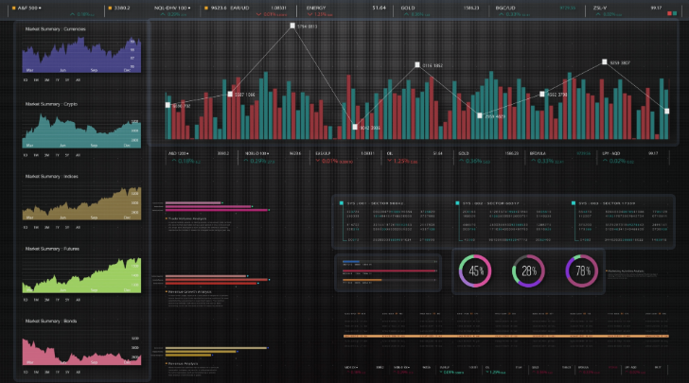
- Executive KPI Dashboard: Focused on high-level metrics (DAU, MAU, Total Revenue) for senior management.
- Retention Analysis Dashboard: Used to track user churn and cohort retention over weeks.
- Revenue & Transaction Dashboard: Detailed breakdown of revenue by region and game type.

CHAPTER 5: SKILLS ACQUIRED

The internship at Rhiti Sports Management Pvt. Ltd. was an intensive and rewarding period that solidified my foundational B.Tech knowledge and transformed it into specialized, industry-ready expertise. The process of building and deploying the E-Gaming Analytics Suite provided hands-on mastery over both the technical infrastructure and the crucial soft skills required for a data-driven role

5.1 Technical Skills Gained
The core of my technical growth focused on strengthening my abilities across the entire data lifecycle: preparation, optimization, and visualization.

5.1.1 Data Analytics and Processing Expertise
- Data Cleaning and Transformation (Python/Pandas): Gained extensive practical experience in cleaning and transforming large, raw gaming and transaction data using Python libraries such as Pandas and NumPy¹. I implemented reusable automation scripts to systematically handle missing values, duplicates, and inconsistent formats. This process optimization reduced the manual data preprocessing time by nearly 20%.
- ETL Pipeline Development: Successfully built and maintained incremental ETL workflows using Python and SQL to automate daily data synchronization from multiple game and transaction database sources ³. This ensures consistent data availability and reliability for automated reporting.
- Exploratory Data Analysis (EDA): Conducted in-depth EDA using statistical and visualization libraries (Matplotlib, Seaborn) to identify behavioural trends, retention patterns, and revenue drivers within the E-Gaming data⁴. The insights derived were directly used to guide product design and marketing strategies.

5.1.2 Database and Query Optimization
- SQL Performance Tuning: Enhanced proficiency in relational databases (MySQL and PostgreSQL) by applying principles of performance engineering. This included analysing query execution plans, implementing optimal indexing strategies, and restructuring complex joins and subqueries.
- Query Optimization Achievement: Through targeted optimization of key reporting queries, I achieved an approximate 15% improvement in data retrieval speed, which was crucial for improving dashboard load times for management.
- Data Integrity and Transactional Updates: Learned to write precise SQL SELECT queries with appropriate WHERE clauses to fetch only the necessary data, and ensured robust, transactional updates to maintain data consistency across the reporting architecture.

5.1.3 Business Intelligence and Visualization (Power BI/DAX)
- Advanced Power BI Dashboard Design: Developed end-to-end interactive dashboards for visualizing complex business metrics, including user engagement, transaction trends, and cohort retention.
- DAX Mastery: Gained practical mastery in writing sophisticated DAX measures for KPI calculations (like ARPU, LTV, and time-intelligence comparisons), enhancing the analytical depth of the reports.
- Custom Visuals and Interactivity: Implemented advanced filtering options, slicers, and drill-through reports, enabling granular analysis by date, user segment, and transaction type, thereby significantly enhancing management-level decision support⁹.
- Data Validation and Quality Assurance: Developed rigorous automated and manual validation models (using Python and Excel) to cross-check outputs, ensuring consistency and accuracy between the database and the dashboard layer. This systematic verification reduced manual validation time by 30%.

5.2 Soft Skills Gained
Working within the agile environment of a specialized division required the refinement of critical professional attributes:
- Systematic Problem-Solving and Resilience: Developed a methodical approach to debugging and solving complex data discrepancies. I learned to isolate variables and systematically track data flow through the ETL pipeline to find the root cause of reporting errors, fostering a proactive approach to data quality.
- Technical Communication and Data Storytelling: Acquired the ability to translate complex analytical and technical findings (e.g., query latency issues or retention patterns) into clear, non-technical business recommendations for product managers and senior management. This skill was crucial for ensuring data-driven insights led to actionable decisions.
- Project Ownership and Accountability: The responsibility for managing production-level reports and ensuring their daily accuracy instilled a strong sense of ownership and meticulous attention to detail. I learned to manage multiple project deadlines, balancing feature development with continuous data validation cycles.
- Cross-Functional Collaboration (Agile): Actively participated in weekly agile review meetings, learning how to effectively incorporate feedback from the Product Management and Finance teams to refine dashboards and analytical models, improving overall usability and decision-making speed.

5.3 Application for Classroom Knowledge
- Database Management Systems (DBMS): Applied theoretical knowledge of normalization, indexing strategies, and relational algebra directly to real-world database optimization tasks (SQL Query Optimization).
- Data Structures and Algorithms: Applied algorithmic thinking to optimize the logic of Python data processing scripts (e.g., optimizing transformation loops) for handling large datasets efficiently.
- Statistics and Probability: Utilized statistical concepts, such as correlation, variance, and hypothesis testing, to perform advanced correlation analysis between user behavior, platform features, and retention rates, providing evidence-based insights.
- Software Engineering Principles: Applied principles like the Single Responsibility Principle and version control best practices (Git) to maintain clean, scalable, and maintainable ETL codebases.

CHAPTER 6: CHALLENGES & SOLUTIONS

Developing a production-ready analytics ecosystem for a high-traffic digital gaming platform introduces several technical, architectural, and operational challenges. The data processed within the E-Gaming Division is high-volume, multi-source, rapidly changing, and directly tied to business-critical KPIs such as Revenue, DAU, MAU, ARPU, Retention, and Conversion Rate.
This chapter outlines the major challenges encountered during the internship, the root causes behind them, and the strategies implemented to systematically resolve them. Each challenge reflects real-world complexities in analytics engineering and demonstrates the practical learning gained during the internship.

Challenge 1: Multi-Source Data Integration & Consistency Issues
Problem Description
The platform collects data from multiple sources—transaction databases (MySQL), user activity logs (PostgreSQL), marketing sheets, and diagnostic log files.
Each system had:
- Different data formats
- Different update frequencies
- Slightly different timestamp conventions
- Missing or inconsistent fields
- Occasional duplicates
This resulted in misaligned metrics, especially for revenue and user activity.
Dashboards would sometimes show mismatched totals between:
- SQL outputs
- Power BI visuals
- Internal Excel trackers
This severely affected stakeholder trust in analytical outputs.

Root Cause Analysis
- No unified schema for data alignment
- Time zone mismatches between systems
- Missing or incomplete ETL transformations
- Lack of automated validation across pipeline layers
- Dirty or partial logs entering the system

Solution Implemented
A multi-step systematic solution was applied:
1. Standardized Data Dictionary
- Created a unified definition sheet for all KPIs.
- Defined exact SQL formulas, DAX measures, and transformation rules.
- Standardized timestamp conversions (UTC → IST).
2. ETL Modernization
- Introduced incremental loading logic in Python.
- Built preprocessing scripts to handle:
  - Null handling
  - Data type corrections
  - String normalization
  - Duplicate removal
3. Validation Automation
- Developed Python-based reconciliation scripts.
- Built Excel audit sheets comparing:
  - Power BI values
  - SQL aggregates
  - Raw transaction files
4. Consistency Alerts
- Added anomaly alerts when differences exceeded threshold limits.

Key Learning
A stable analytics system requires strong consistency guarantees across all layers—raw data, transformations, KPIs, and dashboards. Standardization and automated checks are foundational to reliable reporting.

Challenge 2: High SQL Query Latency & Dashboard Refresh Delays
Problem Description
As the dataset expanded, several dashboards began suffering from:
- Slow refresh times (5–15 minutes per dataset)
- Timeouts during Power BI scheduled refresh
- High CPU usage on SQL servers
- Slow response to drill-down operations
The company relies on high-frequency reporting, so delays directly impacted decision-making.

Root Cause Analysis
- Heavy queries with too many joins
- No indexing on frequently filtered columns
- Full table scans due to missing WHERE clauses
- Repeated computation of aggregated metrics
- Lack of query caching or materialized layers

Solution Implemented
1. Query Profiling
- Used EXPLAIN ANALYZE in PostgreSQL to identify bottlenecks.
- Logged slow queries from server dashboards.
2. Index Optimization
Created indices on:
- user_id
- transaction_date
- game_session
- platform fields frequently used in filters
This alone improved execution time by 20–40%.
3. Query Refactoring
- Removed unnecessary subqueries
- Replaced nested SELECT operations with CTEs
- Simplified joins using dimension tables
- Added LIMIT clauses for staging tables
4. Pre-Aggregated Tables
For metrics like DAU, D1 Retention, and region-wise revenue:
- Built daily summary tables
- Reduced row scanning from millions → thousands
5. Power BI Optimization
- Disabled unnecessary auto-date hierarchies
- Removed columns not used in visuals
- Changed relationships from bi-directional → single direction

Key Learning
Optimizing SQL is not just about writing faster code—it's about designing efficient data models. Indexing, partitioning, and pre-aggregation are essential for enterprise-grade analytics.

Challenge 3: Challenge 3: Power BI Dashboard Performance & Visual Instability
Problem Description
Complex dashboards (Retention, Revenue Flow, Cohort Analysis) initially:
- Took too long to load
- Froze when changing filters
- Returned incomplete data in drill-down views
- Failed scheduled refresh due to DAX engine overload
Stakeholders demanded fast dashboards because they were used daily by senior management.
Root Cause Analysis
- Large dataset size (millions of rows)
- Heavy DAX measures running on the fly
- Multiple slicers increasing filter propagation time
- Improper relationship modelling
- High-cardinality columns (such as user identifiers)
Solution Implemented
1. DAX Optimization
Rewrote heavy DAX measures using:
  - CALCULATE + FILTER pairs instead of SUMX on large tables
  - Using variables inside measures
  - Reducing measure chaining
  - Using DIVIDE() to prevent calculation errors
2. Data Model Restructuring
- Converted flat tables into fact-dimension schema
- Reduced cardinality using surrogate keys
- Removed unnecessary relationships
3. Incremental Refresh Setup
- Configured scheduled incremental refresh:
- Reduced data loads
- Improved refresh time by 25–30%
4. Visual Cleanup
- Removed unnecessary slicers
- Used bookmarks instead of multiple pages
- Replaced costly visuals with optimized ones

Key Learning
A Power BI dashboard is only as good as its data model.
Well-designed star schemas and optimized DAX dramatically improve usability.

Challenge 4: Data Validation & Stakeholder Confidence Issues
Problem Description
Stakeholders often questioned:
- Why KPI values differed from previous reports
- Why Excel numbers didn’t match Power BI
- Whether data was 100% accurate
Without trust, dashboards cannot drive business decisions.

Root Cause Analysis
- Lack of transparent KPI definitions
- Manual validation processes
- Analytical drift due to adjustments in SQL and DAX
- Repeated overwriting of calculations

Solution Implemented
1. Built End-to-End Validation Framework
- Created reconciliation scripts in Python
- Generated daily sanity-check reports
- Built a cross-validation pivot model in Excel
2. Introduced Metric Versioning
Each KPI had:
- Version control
- Documentation
- Owner assignment
3. Data Dictionary Development
- Definitions for every metric
- SQL scripts included in documentation
- DAX logic explained step-by-step

Key Learning
Validation is not an optional step; it is a core requirement in analytics pipelines.
Accuracy directly impacts decision-making quality.

Challenge 5: Cross-Functional Communication & Requirement Alignment
Problem Description
Business requirements from different teams (Product, Marketing, Management) were not always aligned.
This caused:
- Ambiguous KPIs
- Conflicting expectations of dashboard outputs
- Frequent requirement changes

Root Cause Analysis
- Lack of centralized requirement documentation
- Different teams used different definitions of “active user” or “session”
- Miscommunication around SQL vs Power BI logic

Solution Implemented
1. Requirement Consolidation
Created a central KPI requirement sheet that all teams validated.
2. Iterative Feedback Cycles
Weekly sync-ups to:
- Review dashboards
- Confirm definitions
- Update logic
3. Stakeholder Workshops
Explained:
- How dashboards work
- How KPIs are calculated
- Why numbers behave in certain patterns

Key Learning
Communication is as important as technical skill.
Analytics must connect technical accuracy with business clarity.

CHAPTER 7: OVERALL EXPERIENCE & CONCLUSION\

7.1 Summary of Learning Experience
The internship at Rhiti Sports Management Pvt. Ltd. was a transformative professional milestone, offering end-to-end exposure to the real-world analytics ecosystem behind a high-traffic digital gaming platform. The experience bridged the gap between theoretical learning and production-grade implementation, enabling me to work directly on the analytical backbone of the E-Gaming Division.
The most significant learning came from understanding how large-scale gaming platforms depend on a tightly structured data pipeline spanning raw log ingestion, ETL transformations, SQL optimization, BI modelling, and advanced visualization. Throughout this internship, I gained firsthand experience working with:
- Multi-source datasets from transactional systems, telemetry logs, and user behaviour records
- Complex SQL workloads requiring performance tuning for low-latency analytics
- Power BI dashboards powering day-to-day decision-making across the organization
- ETL automation built using Python and SQL for incremental refresh cycles
- Stakeholder-driven analytical development, aligning technical metrics with business KPIs
Working on the full lifecycle of analytical tasks enhanced my ability to design scalable dashboards, write efficient SQL scripts, validate accuracy across systems, and establish structured documentation.
Beyond technical competency, the internship improved my understanding of how product, marketing, analytics, and engineering teams collectively shape platform decisions. Daily interactions with the product managers and the Data Engineering team exposed me to practical constraints such as server limitations, data integrity challenges, and the importance of maintaining KPI consistency across multiple reporting layers.
This internship also cultivated a strong sense of ownership and responsibility. I learned to handle analytical tasks that directly influence business decisions, making accuracy, reliability, and transparency the top priorities in every workflow I developed.

7.2 Future Scope of Work
The work accomplished during the internship lays a robust foundation for the E-Gaming Division’s future analytical improvements. Several areas have been identified where the systems can continue to evolve, scale, and derive increasing value:
1. Predictive Analytics & Machine Learning
With the cleaned, validated datasets now available, the organization is positioned to leverage advanced machine learning models for:
- Churn prediction (D1/D7/D30)
- User segmentation using behavioural clustering
- LTV prediction models
- Fraud detection based on anomalous gameplay patterns
Implementing such models will help the business focus on high-value users, reduce churn, and optimize marketing campaigns.
2. Real-Time Streaming Dashboards
Currently, Power BI dashboards rely on scheduled refresh cycles. Moving toward real-time streaming using tools like:
- Kafka
- Stream Analytics
- Kinesis
- Direct Query-based architectures
would allow management to monitor platform health instantly, reducing reaction time to spikes, drops, or anomalies.
3. Enhanced Cohort Analytics
More detailed cohort dashboards could be built to analyze:
- Weekly/Monthly retention
- Revenue cohorts by acquisition channel
- Correlation between gameplay patterns and monetization behaviour
These insights can guide product teams in designing more effective reward systems and engagement flows.
4. A/B Testing and Experimentation Engine
A dedicated statistical experimentation engine could help run A/B tests for:
- New game mechanics
- UI/UX improvements
- Pricing changes
- Onboarding flows
By applying statistical significance testing, the business can make informed, data-backed decisions.
5. Advanced KPI Monitoring & Alerting
Integrating automated alerts using Python cron jobs or Power Automate could help:
- Detect sudden revenue drops
- Flag unusual gameplay activity
- Identify server-side issues
- Monitor user churn spikes
This moves analytics from passive reporting → proactive monitoring.

7.3 Impact of Internship on Career Goals
This internship played a crucial role in shaping my professional direction and strengthening my commitment toward a career in Data Science, Business Intelligence, and Analytics Engineering.
Before the internship, my understanding of data analytics was primarily academic. However, working on live production systems revealed:
- The complexity of real-world datasets
- The operational importance of low-latency SQL queries
- The value of optimized dashboards for business decisions
- The importance of cross-team communication when building KPIs
- The need for accuracy, reliability, and documentation in analytics ecosystems
The hands-on experience solidified my interest in:
● Data Engineering
Working on ETL pipelines, incremental data loading, and database optimization allowed me to understand the backbone that supports analytical systems.
● Business Intelligence Engineering
Building Power BI dashboards that were used daily by leadership helped me appreciate the role of visualization in simplifying complex data.
● Analytics for Digital Gaming
Understanding user funnels, churn patterns, and revenue flows in an e-gaming context built domain expertise that is highly relevant in the growing gaming industry.
This internship confirmed that my strengths align with roles such as:
- Data Analyst
- Business Intelligence Engineer
- SQL/ETL Developer
- Analytics Engineer
- Data Scientist (entry-level)
The experience also prepared me to contribute immediately to professional environments where high-quality data insights drive business outcomes.

7.4 Conclusions
The internship at Rhiti Sports Management Pvt. Ltd. was an invaluable opportunity to contribute to a real-world gaming analytics ecosystem. The experience strengthened both my technical and professional capabilities, enabling me to work across ETL pipelines, SQL optimization, BI dashboards, validation systems, and cross-functional analytics collaboration.
Working in the E-Gaming Division provided a deep understanding of how data influences gameplay mechanics, user engagement, monetization strategies, and platform health. The internship demonstrated how analytics forms the foundation of modern digital gaming operations.
The combination of technical learning, professional exposure, and high-impact contributions makes this internship a defining milestone in my academic journey and future career in data science and analytics.

WEEKLY WORK LOGS
Week No. | Dates(From-To) | Task Description | Hours Spent | Mentor Signature
1 | Aug 11 – Aug 15 | Onboarding and orientation, introduction to organization policies, meeting the team, getting familiar with the codebase and existing workflows. | 40 | 
2 | Aug 18 – Aug 22 | Performed data cleaning and preprocessing using Excel and Python (Pandas, NumPy) to prepare raw datasets for analysis. | 40 | 
3 | Aug 25 – Aug 29 | Conducted exploratory data analysis (EDA) on gaming and lottery data to identify patterns, anomalies, and key trends. | 40 | 
4 | Sept 01 – Sept 05 | Designed initial versions of Power BI dashboards; integrated data from MySQL and PostgreSQL for reporting. | 40 | 
5 | Sept 08 – Sept 12 | Enhanced Power BI dashboards with interactive filters and visualization improvements; created reports for management insights. | 40 | 
6 | Sept 15 – Sept 19 | Optimized SQL queries for faster data retrieval, automated parts of reporting workflow, and refined dashboards. | 40 | 
7 | Sept 22 – Sept 26 | Finalized dashboards and reports; presented insights on user behavior, transaction trends, and revenue performance. | 40 | 

Week No. | Dates(From-To) | Task Description | Hours Spent | Mentor Signature
1 | Sept 29 – Oct 03 | Integrated multiple datasets into PowerBI, refined dashboard visuals and implemented advanced DAX measures for KPI tracking. | 40 | 
2 | Oct 06 – Oct 10 | Conducted detailed analysis on user transaction data to identify key performance patterns and anomalies. Prepared data validation reports. | 40 | 
3 | Oct 13 – Oct 17 | Enhanced dashboard interactivity with slicers and drill-down functionality, created automated refresh pipelines for updated reports. | 40 | 
4 | Oct 20 – Oct 24 | Performed trend analysis on weekly gaming performance metrics; collaborated with product team to align reports with business goals. | 40 | 
6 | Oct 27 – Oct 31 | Final review and documentation of project deliverables, presented complete Power BI dashboard suite and analytical insights to mentors. | 40 | 

Week No. | Dates(From-To) | Task Description | Hours Spent | Mentor Signature
1 | Nov 03 – Nov 08 | Finished the final projects documentation and fine tuned the Power BI dashboards. | 40 | 
2 | Nov 10 – Nov 11 | Overview of all the dashboards, SQL queries, completed the offboarding formalities. | 40 | 

